Team Description

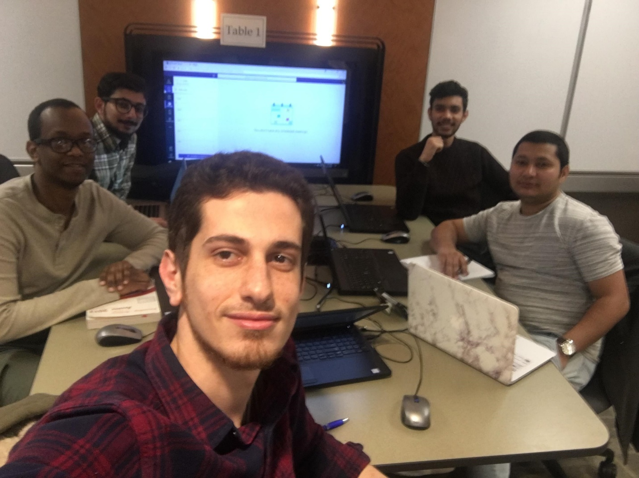

## Project Manager

### Name: Salem Wafi

### Role Description:

* Planning, executing and promoting activities that a project undertakes.
* Responsible for developing and implementing timelines.
* Planning and defining scope of the team
* Developing schedules and estimating time for the project.
* Monitoring and reporting progress of the team in the project

### Skills:

* Programming in Java, Python, MATLAB and Visual Basic
* Database Designing in Oracle and MS SQL Server
* Basic Office
* Graphic Designing in Adobe Photoshop
* Use of Windows Operating Systems
* Strong work ethic
* Fast learner
* Excellent oral, written and visual communication skills.

## Database Analyst

### Name: Yogendra Adhikari

### Role Description:

* Assists in planning, designing, and implementing the database.
* Assist in analysis and design activities associated with the development and maintenance of the database.
* Monitor performance and control plans to identify improvement of the database.
* Design and develop database of the project from scratch.

### Skills:

* Programming in Java and Python
* Database ERD Designing
* Database development using Oracle SQL Developer
* Microsoft Office
* Excellent oral, written and visual communication skills.

## Technical Writer

### Name: Ahmed Hussein

### Role Description:

* Create Documentation about the project with information that is easy to understand.
* Communicate with the clients and show how the final product works.
* Create guides and articles to communicate technical information easily.
* Develop, gather, and disseminate technical information among customers and the team.

### Skills:

* Programming in Java and Python
* Data systems analysis
* Technical Communication
* Microsoft Office
* Excellent oral, written and visual communication skills.

## Back-End Developer

### Name: Shankar Shrestha

### Role Description:

* Develop server-side application logic and integrate work of front-end developer.
* Create a fully functional program which communicates with the database.
* Troubleshoot and debugging of the project application
* Perform tests to optimize communication of the application and database.

### Skills:

* Web development using HTML5, CSS3, JavaScript and Bootstrap
* Programming in Python, Java, C-Sharp, PHP and XML
* Database development using Oracle SQL Developer
* Microsoft Office
* Technical Analysis.

## Front-End Developer

### Name: Suhan Budhathoki

### Role Description:

* Creating UI for the project application.
* Working with back-end developer to optimize performance of the application.
* Gather client feedback and improve the UI which is easier for the client to use.
* Collaborate with the client and back-end developer to improve usability of the application.

### Skills:

* Programming in Java, Python, PHP
* UI Design using HTML5, CSS3 and GUI frameworks
* Database development using Oracle SQL Developer, MySQLi, MS-SQL Server and MS-Access
* Penetration Testing and patching the security
* Microsoft Office